The Book of Revelation
LESSON I
Introductory Material

I. AUTHOR
A. Generally accepted as John.
B. Some doubt through the ages.
C. Evidence
1. Scripture Rev. 1:1, 4:9, 22:8
2. The early church fathers who lived from the end of the first through the end of the third centuries (i.e. Justin Martyr).

3. Johannine type writing
a) "Logos" Rev. 19:13
b) "the Lamb" Rev. 5:6, 12 (and 27 other times)
II. DATE
Near the end of the reign of the Domitian (A.D. 81-96) when persecution of the Christians was probably most severe and widespread. In fact, Christianity was made illegal.

III. PLACE OF WRITING

Patmos Rev. 1:9

IV. METHODS OF INTERPRETATION

A. Preterist –

B. Historical –

C. Futurist –

D. Symbolic –

E. The major difference: time
F. Preferred Method of Interpretation is an “Integrated Method”:

"This problem of time can be solved if the interpreter keeps in mind the nature of the writing. What he saw was not a review of the past nor a preview of the future, but a superview by faith of the living Christ as He lives in His church and overcomes all opposition from within and without. A medley of tenses, present, future, perfect, preterite, testify to John's imaginative journeys from the present into the visionary future and back again. The truths he discloses are common to every age--past, present, and future. They are timeless."

Ray Frank Robbins, The Revelation of Jesus Christ, Nashville: Broadman Press, 1975, pp. 19-20.

V. THE NATURE OF THE WRITING

A. (1:1) "Revelation" (Greek: apokalupsis) "a revealing, an uncovering, or unveiling, or a disclosure."

- Apocalyptic writing--the use of signs, visions, and imagery to convey messages.

- Reasons for it:

- An accepted first century method of offering encouragement.

- Used for protection in case the letter fell into the wrong hands.

- The danger of interpreting apocalyptic language literally. (See Addendum B and Isaiah 34:9, 10; Luke 3:4-6; Rev. 1:16)

B. (1:3) Prophecy

- The primary meaning of prophecy.

- Prophets were primarily concerned with current events.

- Future events were only related as they pertained to current events (e.g. Jeremiah 31:27-34)

The important question to ask when interpreting Revelation is "what did this mean to those who first read it, who lived in the day it was written?" Once that truth is learned that can be applied.

VI. THE REASON FOR WRITING

    - Persecution

    - Gnosticism

"It seems that Revelation was written to meet this two-fold challenge to the church: persecution from without and heresy from within. The corruption of false teachers sapped its strength internally, and the heavy hand of the Roman Empire was attempting to destroy it by persecution."

Robbins, The Revelation of Jesus Christ, p. 26.

VII. OUTLINE OF THE BOOK

- Cyclical, not progressive (see illustration #1)

"The revelation thus provided, to some degree, keeps in view the same points of interest on the horizon of "the things which must come to pass," but with each cycle the view is from a higher perspective. This is not to say revelation contained in the vision of the seven seals is simply repeated in a different mode of expression in the vision of the seven trumpets and then again in the vision of the seven angels with the seven bowls of wrath. Neither do we mean to imply that the three cycles of seven visions contain the whole description of all that John saw. It is not that simple. On the other hand, there is a core of similarity which prevails in the three cycles."

Russell Boatman, What The Bible Says About The End Time (Joplin: College Press Publishing Company., 1983), pp. 61-62.

VIII. THE MAJOR THEME OF THE BOOK

GOD IS IN CONTROL! Satan will be defeated!

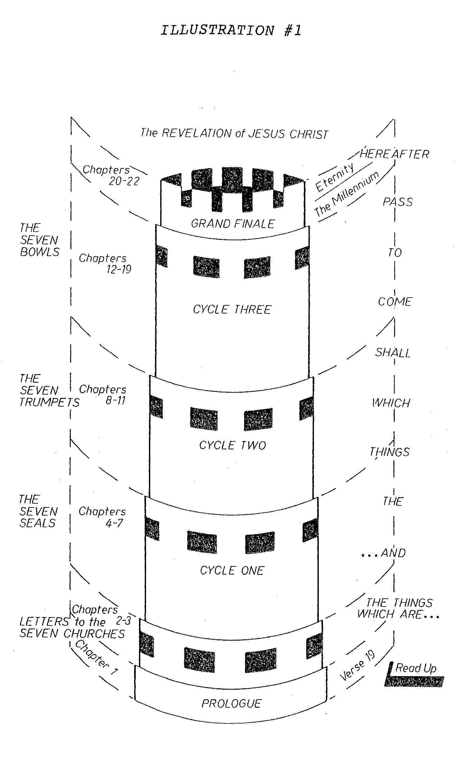

From: Boatman, What the Bible Says About the End Time

